(Output for a third-order system with similar response to a motor with armature)
Error signal to change in setpoint:
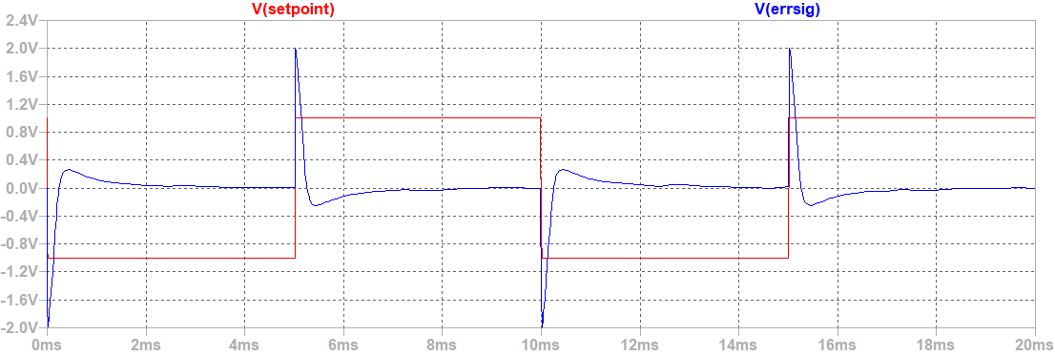
Module responses to error signal (P, I and D respectively):
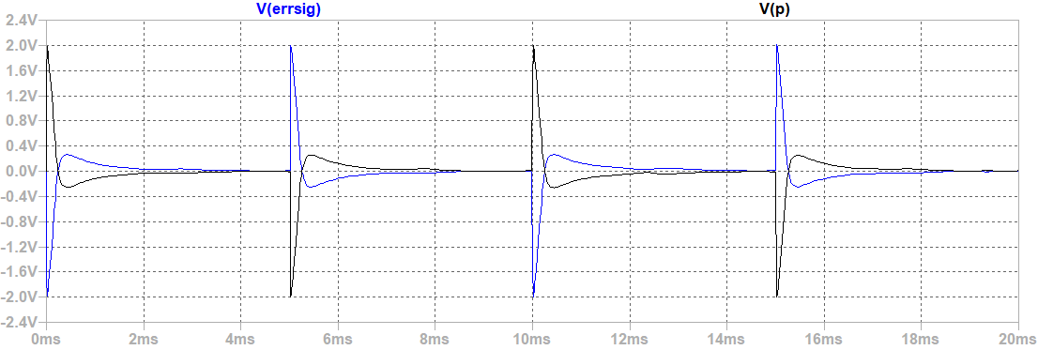
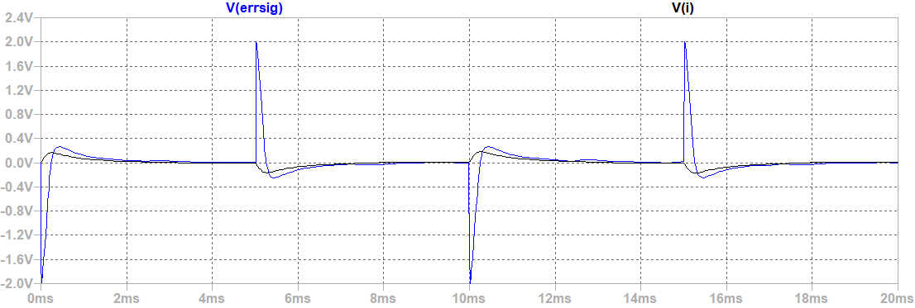
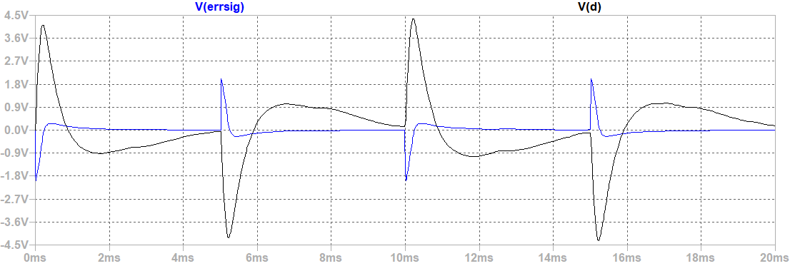
Control signal (weight sum of P, I and D):
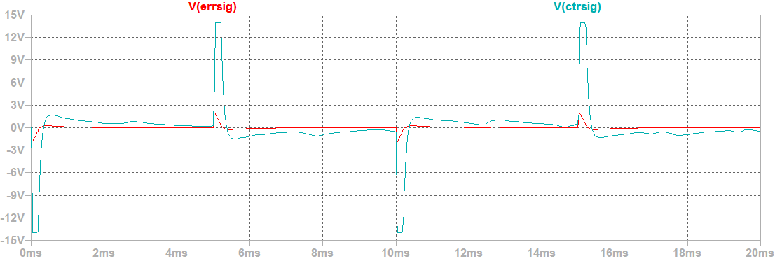
Control signal vs third-order plant response:
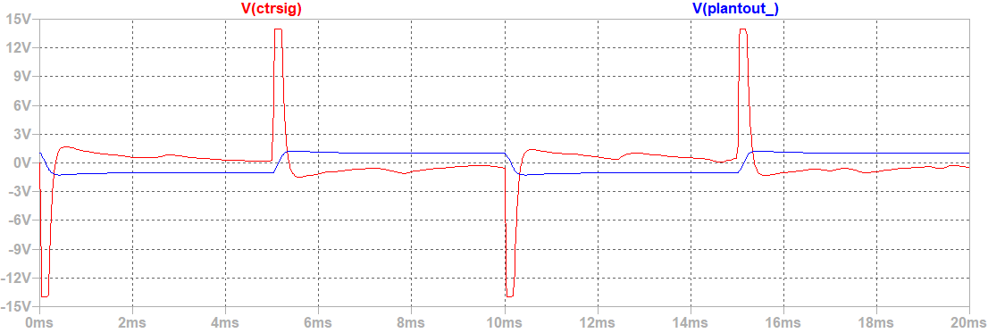
Set-point vs plant response (Closed-loop step response):
